


2025-2028
Student
Code of Conduct

Equity and Excellence: realising the potential of every student
through educational achievement, well-being and engagement and culture and inclusion.
Queensland Department of Education
State Schools Strategy 2025

Purpose

Miallo State School is committed to providing a safe, respectful and disciplined learning environment for all students, staff, parents and visitors.

The Miallo State School Student Code of Conduct sets out the responsibilities and processes we use in our school to promote a productive, effective whole school approach to discipline.

Contact Information
Its purpose is to facilitate high standards of behaviour from all in the school community, ensuring learning and teaching in our school is prioritised, where all students are able to experience success and staff enjoy a safe workplace.

Postal address: | PO Box 173 Mossman Queensland 4873
Phone: | 4213 2555
Email: | office@mialloss.eq.ed.au
School website address: | www.mialloss.eq.edu.au
Contact Person: | Dr Anet Kyiah Ridley (Principal)

Endorsement

Principal Name: | Anet Kyiah Ridley
Principal Signature:
Date:
P/C President and-or School Council Chair Name: | Marcus Wilson
P/C President and-or School Council Chair Signature:
Date:

Contents

Purpose 2

Contact Information 2
Endorsement 2
Contents 3

Principals’ Foreword 4

Learning and Behaviour Statement 5
Consideration of Individual Circumstances 5

Student Wellbeing 5
Whole School Approach to Discipline 6
Behaviour Expectations 6
Differentiated and Explicit Teaching 8
Disciplinary Consequences 12
School Policies 14
Temporary removal of student property 15
Use of mobile phones and other devices by students 17
Preventing and responding to bullying 19
Appropriate use of social media 26
Restrictive Practices 28
Critical Incidents 29

Principal’s Foreword

Miallo State School has a long and proud tradition of providing high quality education to students from our immediate and surrounding areas in Far North Queensland. We believe strong, positive relationships between all members of our school are the foundation to supporting the success of all students. We have an excellent reputation for well-behaved, respectful and friendly students. We have high expectations for the behaviour of our students at all times, whether in school or representing our school in the community at events or excursions.

Our school community has worked together to establish simple, clear and explicit expectations for behaviour. Our school values of honesty and friendship have been used in the development of this Student Code of Conduct, with the aim of helping shape and build the skills of all our students to be confident, self-disciplined and kind young people. Our school staff believe that communication and positive connections with other people are the most valuable skills our communities need now and in the future.
Miallo State School staff take an educative approach to discipline, that behaviour can be taught and that mistakes are opportunities for everyone to learn. Our Student Code of Conduct provides an overview of the school’s local policies on use of mobile phones and other technology, removal of student property and the approach to preventing and addressing incidents of bullying. It also details the steps school staff take to educate students about these policies and how students are explicitly taught the expected behaviours. Finally, it details the consequences that may apply when students breach the expected standards of behaviour, including the use of suspension or exclusion.

Thank you to the students, teachers, parents and other members of the community for their work in bringing this Miallo State School Student Code of Conduct together.

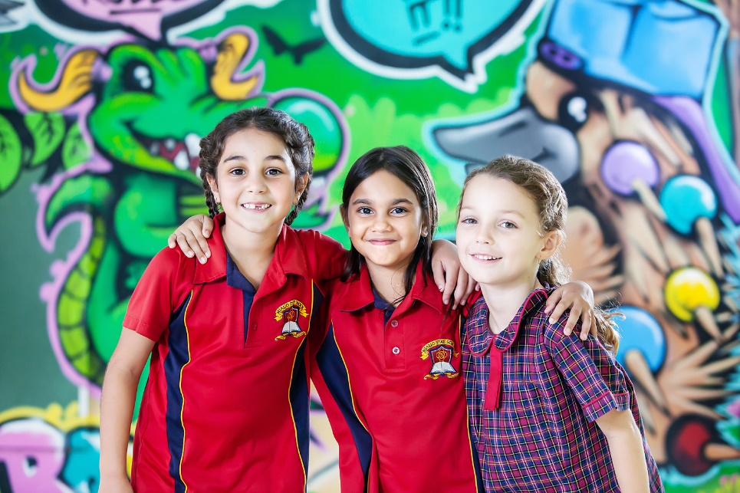

Learning and Behaviour Statement

Systems of Support

Miallo State School uses multi-tiered systems of support as the foundation for our integrated approach to learning and behaviour. This is a preventative, differentiated model grounded in practical strategies, targeted planning and data-informed decision-making, in which school staff match increasingly intensive interventions to the identified needs of individual students.

Consideration of Individual Circumstances

When teaching expectations, responding to inappropriate behaviour or applying a disciplinary consequence, our staff take into account students’ individual circumstances, such as their behaviour history, disability, mental health and wellbeing, religious and cultural considerations, home environment and care arrangements.

In considering the individual circumstances of each student, we recognise that the way we teach, provide support and respond to students, will differ. This reflects the principle of equality, where every student is given the support they need to be successful. This also means that not everyone will be treated the same, because treating everyone the same is not fair.

‘Being fair doesn’t mean giving everyone the same thing.
Being fair means giving people what they need to be successful’.

For example, some students need additional support understand an expectation or more opportunities to practise a required skill or behaviour. For some students, the use of certain disciplinary consequences may be considered inappropriate or ineffective due to complex trauma or family circumstances. These are all matters that our teachers and principal consider with each individual student in both the instruction of, and response to behaviour.

Our teachers are obliged by law to respect and protect the privacy of individual students, so while we understand the interest of other students, staff and parents to know what consequences another student might have received, we will not disclose or discuss this information with anyone but the student’s family. This applies even if the behavioural incident, such as bullying, involves your child. You can be assured that school staff take all matters, such as bullying, very seriously and will address them appropriately. We expect that parents and students will respect the privacy of other students and families.

Student Wellbeing

Miallo State School offers a range of programs and services to support the wellbeing of students in our school, including the delivery of a bespoke well-being program to all classes during weekly lessons, in addition to celebrating and acknowledging a number of well-being events and days. In 2025, staff will also be training in the Berry Street Trauma Informed Practice Model for this to be implemented across the school, to support all of our students. We encourage parents and students to speak with their class teacher if they would like individual advice about accessing particular services.

Learning and wellbeing are inextricably linked: students learn best when their wellbeing is optimised, and they develop a strong sense of wellbeing when they experience success in learning. The student learning and wellbeing framework supports state schools with creating positive school cultures and embedding student wellbeing in all aspects of school life.

Curriculum and pedagogy
The positive impact that a meaningful relationship between staff and students can have on students' academic and social outcomes cannot be understated: positive, respectful relationships are crucial. Schools build the foundations for wellbeing and lifelong learning through curriculum by embedding personal and social capabilities (self-awareness, self-management, social awareness and social management) in the implementation of the P–12 curriculum, assessment and reporting framework.

As part of the whole school's curriculum at Miallo State School, we provide age-appropriate learning through Miallo State School’s well-being program. We also explicitly teach behaviour expectations and have a weekly focus across the school. The PAUSE program, designed to assist students to emotionally self-regulate their behaviour through neuroscience, mindfulness and positive education is a key resource in our program.

Whole School Approach to Discipline

Behaviour Expectations

Miallo State School uses a research-based approach, aligning to Positive Behaviour for Learning (PBL) approaches as the multi-tiered system of support for discipline in the school. This is a whole-school approach, used in all classrooms and programs offered through the school, including sporting activities and excursions. We use these approaches to:
- analyse and improve student behaviour and learning outcomes
- ensure that only evidence-based practices are used correctly by teachers to support students
- continually support staff members to maintain consistent school and classroom improvement practices.

Our staff take responsibility for making their expectations clear, for providing supportive instruction about how to meet these expectations and strive to use behavioural incidents as opportunities to re-teach.

Our staff are committed to delivering a high quality of education for every student, and believe all adults in the school, whether visiting or working, should meet the same three positive behaviour expectations in place for students: being safe, being respectful and being a learner.

Students
Below are examples of what these expectations look like for students across the school. In addition, each classroom will have their own set of examples to help students and visitors understand the expectations and meet the standards we hold for everyone at Miallo State School.

Be Safe
- Hands and feet to yourself.
- Walk on pathways/verandahs.
- Play appropriate school games.
- Report issues to a staff member.
- Cough or sneeze into your elbow.

Be Respectful
- Invite others to join in games.
- Share and play fair.
- Use positive, inclusive language.
- Respect others space and belongings.
- Show kindness and encouragement.

Be a Learner
- Be organised for learning.
- Show whole body listening.
- Do your best work every time.
- Follow staff directions.
- Ask for help when you need it .

Parents and staff
The table below explains the positive behaviour expectations for parents when visiting our school and the standards we commit to as staff.

Be Safe

What we expect to see from you | What you can expect from us
You respect the obligation of staff to maintain student and family privacy. | We will maintain confidentiality about information relating to your child and family.
You leave and collect your child from the designated area at school. | We will give clear guidance about a designated area for parents to leave and collect students.
You use the carpark safely and abide by all road rules during drop off/pick up time. | We will instruct students on safe entry/exit procedures, including leaving school grounds and crossing road.
You share relevant information about your child’s learning, social and behavioural needs with school staff. | We will share relevant information with you about your child’s learning, social and behavioural progress at school.
You keep emergency contact details current. | We will make every attempt to contact an emergency contact in the event we can not contact you.

Be Respectful

What we expect to see from you | What you can expect from us
You make an appointment to speak with the class teacher or Principal to discuss any matters relating to your child. | We will respond as soon as practicable to your request for an appointment and negotiate a mutually agreeable date and time with you.
You are respectful in your conversations at home about school staff. | We will ensure positive behaviours are role modelled for all students.
You recognise people are different and will be non-judgemental, fair and equitable to others in the school community. | We will welcome and celebrate a diverse school community with recognition of significant social, cultural and historical events.
You take a positive, solution-focused approach to resolving complaints. | We will listen to your concerns and attempt to resolve issues.

Be a Learner

What we expect to see from you | What you can expect from us
You support your child to meet the learning and behavioural expectations at school. | We are clear about our learning and behavioural expectations, and will provide feedback about your child’s progress.
You stay informed about school news and activities by reading the school newsletter, diary and other materials sent home by school staff. | We will use the electronic newsletter, diaries and notes home as the primary means of notifying parents about school news, excursions or events.
You approach the class teacher or Principal if you are concerned about the behaviour of a staff member, another student or parent. | We will work with every family to quickly address any complaints or concerns about the behaviour of staff, students or other parents.

Differentiated and Explicit Teaching

Miallo State School has high expectations of students learning and behaviour, and provides differentiated teaching to respond to the needs of all students. This involves teaching expected behaviours and providing opportunities for students to practise them. Teachers reinforce expected behaviours and provide feedback and correction.

Teachers at our school vary what students are taught, how they are taught and how students can demonstrate what they know as part of this differentiated approach to behaviour. Decisions about differentiation are made in response to data and day-to-day monitoring that indicates the behavioural learning needs of students. This enables our teachers to purposefully plan a variety of ways to engage students; assist them to achieve the expected learning; and to demonstrate their learning.

There are three main layers to differentiation, as illustrated in the diagram below. This model is the same used for academic and pedagogical differentiation. Multi-tiered systems of support is a preventative, differentiated model grounded in practical strategies, targeted planning and data-informed decision-making.

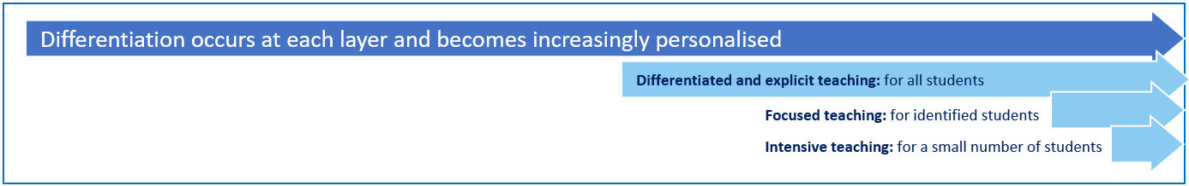

In the behaviour framework, Tier 1 is differentiated and explicit teaching for all students, Tier 2 is focussed teaching for identified students and Tier 3 is intensive teaching for a small number of students. Each layer provides progressively more personalised supports for students.

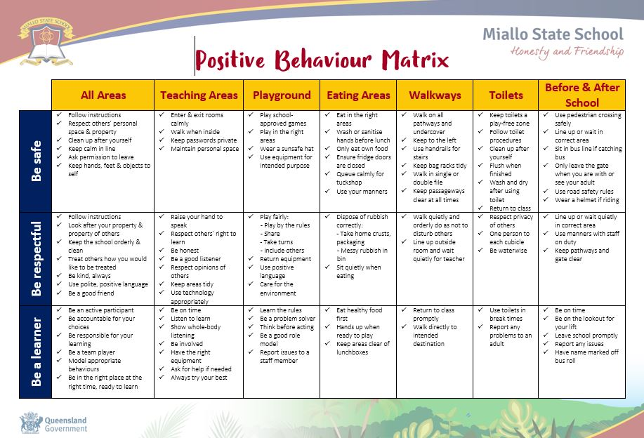
Every classroom in our school uses the Positive Behaviour Expectations Matrix, illustrated below, as a basis for developing their behaviour standards. Using this matrix, the class teacher works with all students to explain exactly what each of the expectations look, sound and feel like in their classroom. The completed matrix is on display in every classroom, used as the basis of teaching expectations throughout the year and revisited regularly to address any new or emerging issues.

Tier 1 Differentiated and explicit teaching for all students

All students in the school receive support for their academic and behavioural development. Focus is on the whole-school implementation of both the Australian Curriculum and positive behaviour expectations. This involves:

- the explicit teaching of behaviours in the setting they will be used
- being consistent when addressing challenging behaviour, while taking developmental norms and behavioural function into account
- providing refresher lessons and targeted recognition throughout the school year
- providing positive reward systems including: Student of the Week; Reward Days; Postcards from the Principal; End of Term Exemplary Behaviour Awards; and Class Conduct pennants. CLASS REWARDS SYSTEMS VARY
- weekly behaviour or SEL focus for week [with accompanying posters]
- behaviour matrix in all classrooms

Tier 2 Focused teaching for identified students

Targeted instruction and supports for some students (10-15%) provide more time and specialisation in services from a range of school-based staff to enable students to meet the required academic and behavioural standards.

Tier 2 supports build on the lessons provided at Tier 1, and may prevent the need for more intensive interventions. Tier 2 supports are provided to small groups of students with similar needs, offering more time and/or detailed instruction on the Australian Curriculum or particular aspects of behaviour expectations. The types of interventions offered at this level will vary according to the needs of each school’s student body, but all have certain things in common:

- there is a clear connection between the skills taught in the interventions and the school-wide expectations.
- interventions require little time of classroom teachers and are easy to sustain
- variations within each intervention are limited
- interventions have a good chance of working (e.g., they are “evidence-based” interventions that are matched to the student’s need).

If the school data indicates that more than 10-15% of students require targeted services, then a review of Tier 1 is needed to address the basic implementation and quality of instruction. Approximately 15% of all students in any school or classroom may require additional support to meet behaviour expectations, even after being provided with differentiated and explicit teaching. These students may have difficulty meeting behavioural expectations in a particular period of the day or as part of a learning area/subject, and focused teaching is provided to help them achieve success.

Focused teaching involves revisiting key behavioural concepts and/or skills and using explicit and structured teaching strategies in particular aspects of a behaviour skill. Focused teaching provides students with more opportunities to practise skills and multiple opportunities to achieve the intended learning and expected behaviour.

Support staff, including teachers with specialist expertise in learning, language or development, work collaboratively with class teachers at Miallo State School to provide focused teaching. Focused teaching is aligned to the Positive Behaviour Matrix, and student progress is monitored by the classroom teacher/s to identify those who:
- no longer require the additional support
- require ongoing focussed teaching
- require intensive teaching.

Tier 3 Intensive Teaching

Research evidence shows that even in an effective, well-functioning school there will always be approximately 5% of the student population who require intensive teaching to achieve behavioural expectations. Intensive teaching involves frequent and explicit instruction, with individuals or in small groups, to develop mastery of basic behavioural concepts, skills and knowledge.

Some students may require intensive teaching for a short period, for particular behaviour skills. Other students may require intensive teaching for a more prolonged period. Decisions about the approach will be made based on data collected from their teacher or teachers, and following consultation with the student’s family.

For a small number of students who continue to display behaviours that are deemed complex and challenging, then individualised, function-based behaviour assessment and support plans and multi-agency collaboration may be provided to support the student. This approach will seek to address the acute impact of barriers to learning and participation faced by students who are negotiating a number of complex personal issues.

Students who require intensive teaching will have a staff member oversee the coordination of their program, communicate with stakeholders and directly consult with the student. Depending on the circumstances, this may be the Principal, classroom teacher or Students with Disabilities Teacher.

Tier 3 supports continue to build on the lessons and supports provided at Tiers 1 and 2, becoming more individualised and more intensive until teams can identify what is needed for a student to be successful. Tier 3 supports are based on the underlying reasons for a student’s behaviour (their FBA) and should include strategies to:

- PREVENT problem behaviour
- TEACH the student an acceptable replacement behaviour
- REINFORCE the student’s use of the replacement behaviour
- MINIMISE the payoff for problem behaviour.

Tier 3 supports exist along a continuum. Many students can benefit from a simple (or brief) Functional Behaviour Assessment (FBA) that identifies unique strategies to help the student achieve success. A smaller percentage of students may require a more comprehensive FBA that includes a more thorough process for data collection, teaming, and problem solving. A much smaller percentage of students may need an intensive FBA and wraparound plan that includes personnel from outside agencies and rigorous problem solving procedures.

Disciplinary Consequences

The disciplinary consequences model used at Miallo State School follows the same differentiated approach used in the proactive teaching and support of student behavioural expectations.

The majority of students will be confident and capable of meeting established expectations that are clear, explicitly taught and practised.

Some students will need additional support, time and opportunities to practise expected behaviours. Approximately 15% of the student population may experience difficulty with meeting the stated expectations, and even with focussed teaching, in-class corrective feedback, sanctions and rule reminders continue to display low-level problem behaviour. This can interfere with teaching and learning for the whole class, and the class teacher may refer the student to the school administration team immediately for determination of a disciplinary consequence.

For a small number of students, approximately 2-5%, a high level of differentiated support or intensive teaching is required to enable them to meet the behavioural expectations. This may be needed throughout the school year on a continuous basis. The determination of the need will be made by the principal in consultation with staff and other relevant stakeholders. On occasion the behaviour of a student may be so serious, such as causing harm to other students or to staff, that the principal may determine that an out of school suspension or exclusion is a necessary consequence for the their behaviour. Usually this course of action is only taken when the behaviour is either so serious as to warrant immediate removal of the student for the safety of others, and no other alternative discipline strategy is considered sufficient to deal with the problem behaviour.

The differentiated responses to problem behaviour can be organised into three tiers, with increasing intensity of support and consequences to address behaviour that endangers others or causes major, ongoing interference with class or school operations.

Differentiated

Class teacher provides in-class or in-school disciplinary responses to low-level or minor problem behaviour. This may include:
- Pre-correction (e.g. “Remember, walk quietly to your seat”)
- Non-verbal and visual cues (e.g. posters, hand gestures)
- Whole class practising of routines
- Corrective feedback (e.g. “Hand up when you want to ask a question”)
- Rule reminders (e.g. “When the bell goes, stay seated until I dismiss you”)
- Explicit behavioural instructions (e.g. “Pick up your pencil”)
- Proximity control
- Tactical ignoring of inappropriate behaviour
- Revised seating plan and relocation of student/s
- Individual positive reinforcement for appropriate behaviour
- Classwide incentives
- Reminders of incentives or class goals
- Redirection
- Low voice and tone for individual instructions
- Provide positive choice of task order (e.g. “Which one do you want to start with?”)
- Prompt student to take a break or time away in class
- Model appropriate language, problem solving and verbalise thinking process (e.g. “I’m not sure what is the next step, who can help me?”)
- Provide demonstration of expected behaviour
- Peer consequence (e.g. corrective feedback to influential peer demonstrating same problem behaviour)
- Private discussion with student about expected behaviour
- Reprimand for inappropriate behaviour
- Warning of more serious consequences (e.g. removal from classroom)
- Detention or Blue Slip (for repeated behaviour)

Focussed

Class teacher is supported by other school-based staff to address in-class problem behaviour. This may include:
- Functional Behaviour Assessment
- Individual student behaviour support strategies (e.g. individual behaviour plan)
- Targeted skills teaching in small group
- Detention or Blue Slip
- Behavioural contract or plan
- Counselling and guidance support
- Self-monitoring plan
- Check in Check Out strategy
- Teacher coaching and debriefing
- Referral to Student Support Services team for support
- Stakeholder meeting with parents and external agencies

Intensive

School leadership team work in consultation with Student Support Network to address persistent or ongoing serious problem behaviour. This may include:
- Functional Behaviour Assessment and Individual Behaviour Support Plan
- Complex case management and review
- Stakeholder meeting with parents and external agencies including regional specialists
- Short term suspension (up to 10 school days)
- Long term suspension (up to 20 school days)
- Charge related suspension (student has been charged with a serious criminal offence is suspended from school until the charge has been dealt with by the relevant justice authorities)
- Suspension pending exclusion (student is suspended from school pending a decision by the Director-General or delegate (principal) about their exclusion from school)
- Exclusion (student is excluded from a particular state school site, a group of state schools or all state schools in Queensland for a defined period of time or permanently)
- Cancellation of enrolment for students older than compulsory school age who refuse to participate in the educational program provided at the school.

School Disciplinary Absences

A School Disciplinary Absence (SDA) is an enforced period of absence from attending a Queensland state school, applied by the Principal as a consequence to address poor student behaviour. There are four types of SDA:
- Short suspension (1 to 10 school days)
- Long suspension (11 to 20 school days)
- Charge-related suspension
- Exclusion (period of not more than one year or permanently).

At Miallo State School, the use of any SDA is considered a very serious decision. It is typically only used by the Principal when other options have been exhausted or the student’s behaviour is so dangerous that continued attendance at the school is considered a risk to the safety or wellbeing of the school community.

Parents and students may appeal a long suspension, charge-related suspension or exclusion decision. A review will be conducted by the Director-General or their delegate, and a decision made within 40 schools days to confirm, amend/vary or set aside the original SDA decision by the Principal.

The appeal process is a thorough review of all documentation associated with the SDA decision and provides an opportunity for both the school and the family to present their case in the matter. Time is afforded for collection, dissemination and response to the materials by both the school and the family. It is important that the purpose of the appeal is understood so that expectations are clear, and appropriate supports are in place to ensure students can continue to access their education while completing their SDA.

Re-entry following suspension
Students who are suspended from Miallo State School may be invited to attend a re-entry meeting on the day of their scheduled return to school. The main purpose of this meeting is to welcome the student, with their parent/s, back to the school. It is not a time to review the student’s behaviour or the decision to suspend. The aim of the re-entry meeting is for school staff to set the student up for future success and strengthen home-school communication.

It is not mandatory for the student or their parents to attend a re-entry meeting. It may be offered as a support for the student to assist in their successful re-engagement in school following suspension.

Arrangements
The invitation to attend the re-entry meeting will be communicated via telephone and in writing, usually via email. Re-entry meetings are short, taking less than 10 minutes, and kept small with only the Principal or their delegate attending with the student and their parent/s.

A record of the meeting is saved in OneSchool, under the Contact tab, including any notes or discussions occurring during the meeting.

Structure
The structure of the re-meeting should follow a set agenda, shared in advance with the student and their family. If additional items are raised for discussion, a separate arrangement should be made to meet with the parent/s at a later date and time. This meeting should be narrowly focussed on making the student and their family feel welcome back into the school community.

Possible agenda:
- Welcome back to school
- Check in on student wellbeing
- Discuss any recent changes to school routine or staffing
- Offer information about supports available (e.g. guidance officer)
- Set a date for follow-up
- Thank student and parent/s for attending
- Walk with student (or direct) to classroom

Reasonable adjustments
In planning the re-entry meeting, school staff will consider reasonable adjustments needed to support the attendance and engagement of the student. This includes selecting an appropriate and accessible meeting space, organising translation or interpretation services or supports (e.g. AUSLAN), provision of written and/or pictorial information and other relevant accommodations. The inclusion of support staff, such as guidance officers or Community Education Counsellors, may also offer important advice to ensure a successful outcome to the re-entry meeting.

School Policies

Miallo State School has tailored school discipline policies designed to ensure students, staff and visitors work cooperatively to create and maintain a supportive and safe learning environment. Please ensure that you familiarise yourself with the responsibilities for students, staff and visitors outlined in the following policies:

- Temporary removal of student property
- Use of mobile phones and other devices by students
- Preventing and responding to bullying
- Appropriate use of social media

Temporary removal of student property

The removal of any property in a student’s possession may be necessary to promote the caring, safe and supportive learning environment of the school, to maintain and foster mutual respect between all state school staff and students. The Temporary removal of student property by school staff procedure outlines the processes, conditions and responsibilities for state school principals and school staff when temporarily removing student property.

In determining what constitutes a reasonable time to retain student property, the principal or state school staff will consider:
- the condition, nature or value of the property
- the circumstances in which the property was removed
- the safety of the student from whom the property was removed, other students or staff members
- good management, administration and control of the school.

The Principal or state school staff determine when the temporarily removed student property can be returned, unless the property has been handed to the Queensland Police Service.

The following items are explicitly prohibited at Miallo State School and will be removed if found in a student’s possession:

- illegal items or weapons (e.g. guns, knives*, throwing stars, chains)
- imitation guns or weapons
- potentially dangerous items (e.g. blades, rope)
- drugs** (including tobacco)
- alcohol
- aerosol deodorants or cans (including spray paint)
- explosives (e.g. fireworks, flares, sparklers)
- flammable solids or liquids (e.g. fire starters, mothballs, lighters)
- poisons (e.g. weed killer, insecticides)
- inappropriate or offensive material (e.g. racist literature, pornography, extremist propaganda).

* No knives of any type are allowed at school [including flick knives, pocket knives, ballistic knives, sheath knives, push daggers, trench knives, butterfly knives, star knives, butter knives, fruit knives or craft knives] or any item that can be used as a weapon, for example a chisel. Knives needed for school activities will be provided by the school, and the use of them will be supervised by school staff. In circumstances where students are required to have their own knives or sharp tools for particular subjects or vocational courses, the school will provide information about the procedures for carrying and storing these items at school.

Responsibilities

State school staff at Miallo State School:
- do not require the student’s consent to search school property such as desks or laptops that are supplied to the student through the school;
- may seize a student’s bag where there is suspicion that the student has a dangerous item (for example, a knife) in their school bag, prior to seeking consent to search from a parent or calling the police;
- consent from the student or parent is required to examine or otherwise deal with the temporarily removed student property. For example, staff who temporarily remove a mobile phone from a student are not authorised to unlock the phone or to read, copy or delete messages stored on the phone;
- there may, however, be emergency circumstances where it is necessary to search a student’s property without the student’s consent or the consent of the student’s parents (e.g. to access an EpiPen for an anaphylactic emergency);
- consent from the student or parent is required to search the person of a student (e.g. pockets or shoes). If consent is not provided and a search is considered necessary, the police and the student’s parents should be called to make such a determination.

Parents of students at Miallo State School
- ensure your children do not bring property onto schools grounds or other settings used by the school (e.g. camp, sporting venues) that:
  - is prohibited according to our Student Code of Conduct
  - is illegal
  - puts the safety or wellbeing of others at risk
  - does not preserve a caring, safe, supportive or productive learning environment
  - does not maintain and foster mutual respect;
- collect temporarily removed student property as soon as possible after they have been notified by the Principal or state school staff that the property is available for collection.

Students of Miallo State School
- do not bring property onto school grounds or other settings used by the school (e.g. camp, sporting venues) that:
  - is prohibited according to our Code of Conduct
  - is illegal
  - puts the safety or wellbeing of others at risk
  - does not preserve a caring, safe, supportive or productive learning environment
  - does not maintain and foster mutual respect;
- collect their property as soon as possible when advised by the Principal or state school staff it is available for collection.

Use of mobile phones and other devices by students

Digital literacy refers to the skills needed to live, learn and work in a society where communication and access to information is dominated by digital technologies like mobile phones. However, the benefits brought about through these diverse technologies can be easily overshadowed by deliberate misuse which harms others or disrupts learning.

In consultation with the broader school community, Miallo has determined that explicit teaching of responsible use of devices is a critical component of digital literacy. The knowledge and confidence to navigate and use these technologies safely while developing digital literacy is a responsibility shared between parents, school staff and students.

It is also agreed that personal mobile phones and devices such as ipads or ipods, are not allowed at our school. In the event students require such a device [for eg. bus travel] they are to be handed in to the office for safe keeping upon entry to school, and collected at hometime. Leaving devices in their school bags put them at risk of being stolen or damaged, and staff take no responsibility for these devices if they are brought to school.

Responsibilities

The responsibilities for students using devices at school such as ipads or during school activities, are outlined below.

It is acceptable for students at Miallo State School to:
- use school devices for
  - assigned class work and assignments set by teachers
  - developing appropriate literacy, communication and information skills
  - authoring text, artwork, audio and visual material for publication on the intranet or internet for educational purposes as supervised and approved by the school
  - conducting general research for school activities and projects
  - communicating or collaborating with other students, teachers, parents or experts in relation to school work
  - accessing online references such as dictionaries, encyclopaedias, etc.
  - researching and learning through the department's eLearning environment
- be courteous, considerate and respectful of others when using a mobile device
- seek teacher's approval where they wish to use a mobile device under special circumstances.

It is unacceptable for students at Miallo State School to:
- use a mobile phone or other devices in an unlawful manner
- download, distribute or publish offensive messages or pictures
- use obscene, inflammatory, racist, discriminatory or derogatory language
- use language and/or threats of violence that may amount to bullying and/or harassment, or even stalking
- insult, harass or attack others or use obscene or abusive language
- deliberately waste printing and internet resources
- damage computers, printers or network equipment
- commit plagiarism or violate copyright laws
- ignore teacher directions for the use of social media, online email and internet chat
- send chain letters or spam email (junk mail)
- knowingly download viruses or any other programs capable of breaching the department's network security
- use in-phone cameras anywhere a normal camera would be considered inappropriate, such as in change rooms or toilets
- invade someone's privacy by recording personal conversations or daily activities and/or the further distribution (e.g. forwarding, texting, uploading, Bluetooth use etc.) of such material
- use a device to cheat during exams or assessments
- take into or use mobile devices at exams or during class assessment unless expressly permitted by school staff.

At all times students, while using ICT facilities and devices supplied by the school, will be required to act in line with the requirements of the Miallo State School Student Code of Conduct. In addition students and their parents should:
- understand the responsibility and behaviour requirements (as outlined by the school) that come with accessing the department’s ICT network facilities
- ensure they have the skills to report and discontinue access to harmful information if presented via the internet or email
- be aware that:
  - access to ICT facilities and devices provides valuable learning experiences for students and supports the school's teaching and learning programs
  - the school is not responsible for safeguarding information stored by students on departmentally-owned student computers or mobile devices
  - schools may remotely access departmentally-owned student computers or mobile devices for management purposes
  - students who use a school's ICT facilities and devices in a manner that is not appropriate may be subject to disciplinary action by the school, which could include restricting network access
  - despite internal departmental controls to manage content on the internet, illegal, dangerous or offensive information may be accessed or accidentally displayed
  - teachers will always exercise their duty of care, but avoiding or reducing access to harmful information also requires responsible use by the student.

Preventing and responding to bullying

Miallo State School uses the Australian Student Wellbeing Framework to promote positive relationships and the wellbeing of all students, staff and visitors at the school.

Our staff know student learning is optimised when they feel connected to others and experience safe and trusting relationships. Students who feel secure are more likely to be active participants in their learning and to achieve better physical, emotional, social and educational outcomes. Teachers who feel valued and supported are more likely to engage positively with students and build stronger connections within the school community. Parents who are positively engaged with their child’s education leads to improved student self-esteem, attendance and behaviour at school. Enhancing the wellbeing of students and their educators delivers overall long-term social, health and economic benefits to the Australian community.

Miallo State School has a Student Representative Council, who meet regularly with the school leadership team to promote strategies to improve student wellbeing, safety and learning outcomes. The standing items on the agenda for each Student Leadership Forum are the core elements of the Australian Student Wellbeing Framework:

- Leadership
Principals and school leaders playing an active role in building a positive learning environment where the whole school community feels included, connected, safe and respected.

- Inclusion
All members of the school community actively participating in building a welcoming school culture that values diversity, and fosters positive, respectful relationships.

- Student voice
Students actively participate in their own learning and wellbeing, feel connected and use their social and emotional skills to be respectful, resilient and safe.
- Partnerships
Families and communities collaborating as partners with the school to support student learning, safety and wellbeing.

- Support
School staff, students and families sharing and cultivating an understanding of wellbeing and positive behaviour and how this supports effective teaching and learning.

A priority for the Student Leadership Forum is contributing to the implementation of strategies that enhance wellbeing, promote safety and counter violence, bullying and abuse in all online and physical spaces. The engagement of young people in the design of technology information and digital education programs for parents was a key recommendation from the Queensland Anti-Cyberbullying Taskforce report in 2018, and at Miallo State School we believe students should be at the forefront of advising staff, parents and the broader community about emerging issues and practical solutions suitable to different contexts.

Bullying

The agreed national definition for Australian schools describes bullying as
- ongoing and deliberate misuse of power in relationships through repeated verbal, physical and/or social behaviour that intends to cause physical, social and/or psychological harm;
- involving an individual or a group misusing their power, or perceived power, over one or more persons who feel unable to stop it from happening;
- happening in person or online, via various digital platforms and devices and it can be obvious (overt) or hidden (covert). Bullying behaviour is repeated, or has the potential to be repeated, over time (for example, through sharing of digital records);
- having immediate, medium and long-term effects on those involved, including bystanders. Single incidents and conflict or fights between equals, whether in person or online, are not defined as bullying.

Behaviours that do not constitute bullying include:
- mutual arguments and disagreements (where there is no power imbalance)
- not liking someone or a single act of social rejection
- one-off acts of meanness or spite
- isolated incidents of aggression, intimidation or violence.

However, these conflicts are still considered serious and need to be addressed andresolved. At Miallo State School our staff will work to quickly respond to any matters raised of this nature in collaboration with students and parents.

The following flowchart explains the actions Miallo State School teachers will take when they receive a report about student bullying, including bullying which may have occurred online or outside of the school setting. Please note that the indicative timeframes will vary depending on the professional judgment of teachers who receive the bullying complaint and their assessment of immediate risk to student/s.

Miallo State School - Bullying response flowchart for teachers

Please note these timelines may be adjusted depending on the unique circumstances and risk associated with each situation. This is at the professional judgment of the staff involved. Timeframes should be clearly discussed and agreed with student and family.

Key contacts for students and parents to report bullying:
Prep to Year 6 – Class teacher

First hour
Listen
- Provide a safe, quiet space to talk
- Reassure the student that you will listen to them
- Let them share their experience and feelings without interruption
- If you hold immediate concerns for the student's safety, let the student know how you will address these. Immediate in this circumstance is where the staff member believes the student is likely to experience harm (from others or self) within the next 24 hours

Cyberbullying
- Gather additional information from other students, staff or family
- Review any previous reports or records for students involved
- Make sure you can answer who, what, where, when and how
- Clarify information with student and check on their wellbeing
Day two
Collect
- Ask the student for examples they have of the alleged bullying (e.g. hand written notes or screenshots)
- Write a record of your communication with the student
- Check back with the student to ensure you have the facts correct
- Enter the record in OneSchool
- Notify parent/s that the issue of concern is being investigated
Day one
Document
- Meet with the student to review situation
- Discuss what has changed, improved or worsened
- Explore other options for strengthening student wellbeing or safety
- Report back to parent
- Record outcomes in OneSchool
Day five
Review
- Continue to check in with student on regular basis until concerns have been mitigated
- Record notes of follow-up meetings in OneSchool
- Refer matter to specialist staff within 48 hours if problems escalate
- Look for opportunities to improve school wellbeing for all students
Ongoing
Follow up
- Evaluate the information to determine if bullying has occurred or if another disciplinary matter is at issue
- Make a time to meet with the student to discuss next steps
- Ask the student what they believe will help address the situation
- Engage the student as part of the solution
- Provide the student and parent with information about student support network
- Agree to a plan of action and timeline for the student, parent and yourself
Day three
Discuss
- Document the plan of action in OneSchool
- Complete all actions agreed with student and parent within agreed timeframes
- Monitor student and check in regularly on their wellbeing
- Seek assistance from student support network if needed
Day four
Implement

Cyberbullying is treated at Miallo State School with the same level of seriousness as in-person bullying. The major difference with cyberbullying however, is that unlike in-person bulling, cyberbullying follows students into their community, their homes and their bedrooms, giving them no opportunity to escape the harassment or abuse during the evening, weekends or holidays.

In the first instance, students or parents who wish to make a report about cyberbullying should approach the regular class teacher (for students in primary year levels) or the Principal.

It is important for students, parents and staff to know that state school principals have the authority to take disciplinary action to address student behaviours that occur outside of school hours or school grounds. This includes cyberbullying. Parents and students who have concerns about cyberbullying incidents occurring during school holidays should immediately seek assistance through the Office of the e-Safety Commissioner or the Queensland Police Service.

Students enrolled at Miallo State School may face in-school disciplinary action, such as detention or removing of privileges, or more serious consequences such as suspension or exclusion from school for engaging in behaviour that adversely affects, or is likely to adversely affect, other students or the good order and management of the school. This includes behaviour such as cyberbullying which occurs outside of school hours or settings, for example on the weekend or during school holidays. It also applies to inappropriate online behaviour of enrolled students that is directed towards other community members or students from other school sites.

Parents or other stakeholders who engage in inappropriate online behaviour towards students, staff or other parents may be referred to the Office of the e-Safety Commissioner and/or the Queensland Police Service. State school staff will be referred for investigation to the Integrity and Employee Relations team in the Department of Education. Any questions or concerns about the school process for managing or responding to cyberbullying should be directed to the Principal.

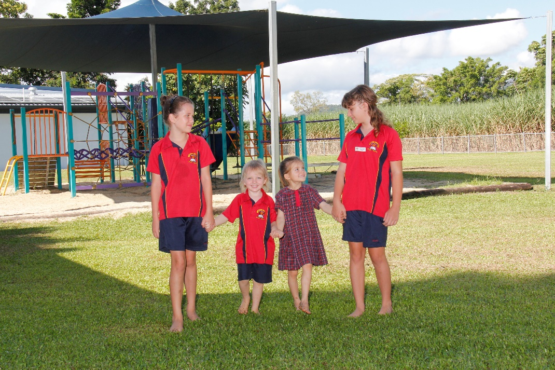

Miallo State School - Cyberbullying response flowchart for school staff

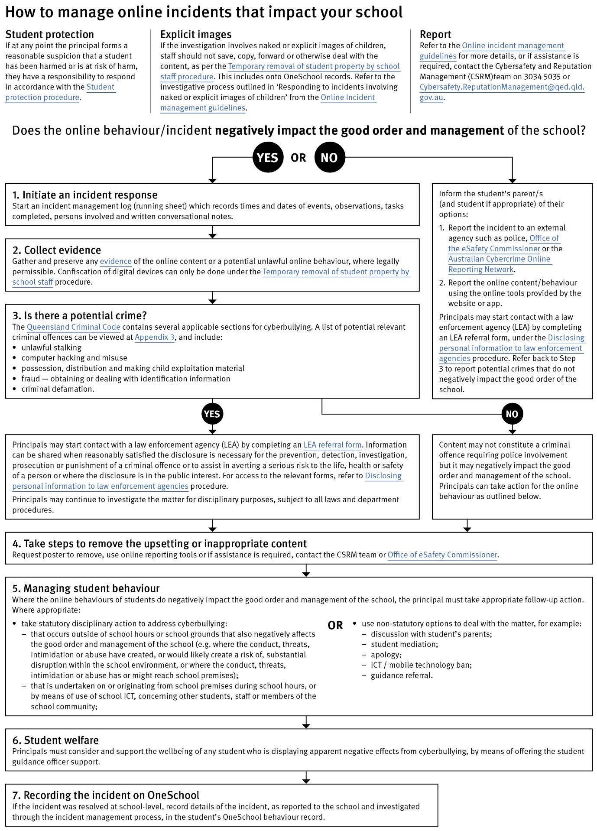

Cybersafety and Reputation Management (CRM)

The Department of Education employs a dedicated team of experts to assist in maintaining the integrity of the department's reputation with regards to cybersafety and reputation management issues, effectively leading the development and implementation of departmental cybersafety processes.

This team provides direct support for schools to respond to concerns of inappropriate online behaviour and misuse of information and communication technology.

The team provides a guide for parents with important information about cybersafety and cyberbullying, and suggestions about what you can do if your child is a target or responsible for inappropriate online behaviour.

The team has also developed a Cyberbullying and reputation management (Department employees only) resource to assist principals in incident management.

For more information about cybersafety sessions at your school, or for assistance with issues relating to online behaviour, contact the team (Department employees only).

Student Intervention and Support Services

Miallo State School recognises the need to provide intervention and support to all students involved in incidents of bullying, including cyberbullying.

Students who have been subject or witness to bullying have access to a range of internal support staff, as identified in the Student Support Network section earlier in this document. Students are, however, also encouraged to approach any staff member with whom they feel comfortable sharing their concerns, regardless of their role in the school. All staff at Miallo State School are familiar with the response expectations to reports of bullying, and will act quickly to ensure students’ concerns are addressed. Depending on the nature of the reported bullying incident, a formal plan of action may be developed and documented to support the implementation of strategies to assist the student.

Students who engage in bullying behaviours towards others will also be provided with support to assist them to use more socially acceptable and appropriate behaviours in their interactions. This includes counselling, social development programs, referral to mental health services or involvement in a restorative justice strategy. School disciplinary measures may also be used to reinforce the seriousness with which the community takes all incidents of bullying. These measures may include internal school suspension, withdrawal from social events or celebrations or more severe punishments such as suspension or exclusion from school.
Miallo State School – Anti-Bullying Compact

The Anti-Bullying Compact provides a clear outline of the way our community at Miallo State School works together to establish a safe, supportive and disciplined school environment. This compact is provided to all students and their parents upon enrolment, and may be revisited with individual students if particular problems around bullying arise.

Miallo State School – Anti Bullying Compact

We agree to work together to improve the quality of relationships in our community at Miallo State School. It is through intentional consideration of our behaviour and communication that we can reduce the occurrence of bullying, and improve the quality of the schooling experience for everyone.

The agreed national definition for Australian schools describes bullying as
- ongoing and deliberate misuse of power in relationships through repeated verbal, physical and/or social behaviour that intends to cause physical, social and/or psychological harm;
- involving an individual or a group misusing their power, or perceived power, over one or more persons who feel unable to stop it from happening;
- happening in person or online, via various digital platforms and devices and it can be obvious (overt) or hidden (covert). Bullying behaviour is repeated, or has the potential to be repeated, over time (for example, through sharing of digital records);
- having immediate, medium and long-term effects on those involved, including bystanders. Single incidents and conflict or fights between equals, whether in person or online, are not defined as bullying.

We believe that no one deserves to be mistreated and that everyone regardless of race, colour, religion, immigration status, nationality, size, gender, popularity, athletic capability, academic outcomes, social ability, or intelligence has the right to feel safe, secure, and respected.

I agree to:
- Treat everyone with kindness and respect.
- Abide by the school’s anti-bullying policies and procedures.
- Support individuals who have been bullied.
- Speak out against verbal, relational, physical bullying and cyber bullying.
- Notify a parent, teacher, or school administrator when bullying does occur.

Student’s signature

Parent’s signature

School representative signature

Date

Appropriate use of social media

The internet, mobile phones and social media provide wonderful opportunities for students to network and socialise online. While these technologies provide positive platforms for sharing ideas, they also have the potential to cause pain and suffering to individuals, groups or even whole communities.

It’s important to remember that sometimes negative comments posted about the school community have a greater impact than expected. This guide offers some information about how to use social media in relation to comments or posts about the school community. Reputations of students, teachers, schools, principals and even parents can be permanently damaged — and in some cases, serious instances of inappropriate online behaviour are dealt with by police and the court system.

Being aware of a few simple strategies can help keep the use of social media positive and constructive:
- Before you post something online, ask yourself if the community or individual really need to know. Is it relevant, positive and helpful?
- Remember that what you post online is a direct reflection of who you are. People will potentially form lasting opinions of you based on what you post online.
- Be a good role model. If things get heated online consider logging out and taking a few moments to relax and think. Hasty, emotive responses could inflame situations unnecessarily.
- Be mindful when commenting, try to keep general and avoid posting anything that could identify individuals.
- A few years ago parents may have discussed concerns or issues with their friends at the school gate. Today with the use of social media, online discussions between you and your close friends can very quickly be shared with a much wider audience, potentially far larger than intended.
- Taking a few moments to think about the content you are about to post could save upset, embarrassment, and possible legal action.
- As a parent you have a role in supervising and regulating your child’s online activities at home and its impact on the reputation and privacy of others. Parents are their child’s first teachers — so they will learn online behaviours from you.

Is it appropriate to comment or post about schools, staff or students?

Parental and community feedback is important for schools and the department. If you have a compliment, complaint or enquiry about an issue at school, the best approach is to speak directly to the school about the matter, rather than discussing it in a public forum.

While many schools use social media to update parents of school notices, the department prefers that parents contact schools directly with a compliment, complaint or enquiry due to privacy considerations. Imagine if your doctor, accountant or banking institution tried to contact you to discuss important matters via Facebook.

If you have raised an issue with a school or know that another person has, consider refraining from discussing those details on social media, particularly the names of anyone involved.

Keep comments calm and polite, just as you would over the telephone or by email. If you encounter negative or derogatory content online which involves the school, hinders a child’s learning and/or affects the school community at large, contact the school principal.

Possible civil or criminal ramifications of online commentary

A serious instance of inappropriate online behaviour may constitute a criminal offence and become a police matter. For example, online content may substantiate the offence of ‘using a carriage service to menace, harass or cause offence’ (Criminal Code Act 1995 (Cth) s. 474.17). School staff may contact their union or obtain personal legal advice if they feel that online content seriously impacts their reputation. Defamatory online content may give rise to litigation under the Defamation Act 2005 (Qld).

What about other people’s privacy?

If you upload photos of your children, be mindful of who might be in the background. You might be happy to share your child’s successes with your friends and family via social media, but some parents are not. If you are tagging or naming students, consider that other parents may not want their child’s name attached to images online.

What if I encounter problem content?

Taking the following steps may help resolve the issue in a constructive way:
- refrain from responding
- take a screen capture or print a copy of the concerning online content
- if you consider problem content to be explicit, pornographic or exploitative of minors, you should keep a record of the URL of the page containing that content but NOT print or share it. The URL can be provided to the school principal, or police, as needed for escalation of serious concerns
- block the offending user
- report the content to the social media provider.

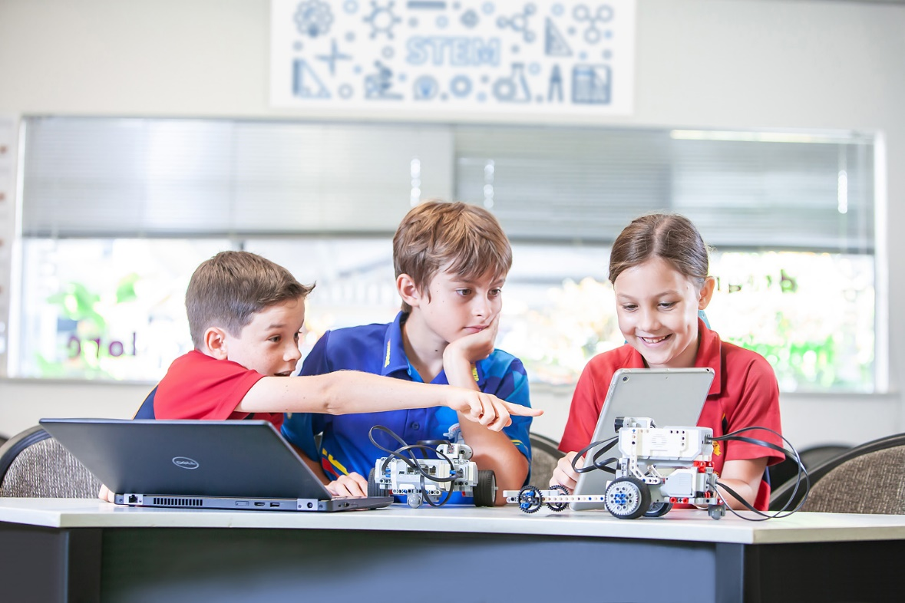

Restrictive Practices

School staff at Miallo State School need to respond to student behaviour that presents a risk of physical harm to the student themselves or others. It is anticipated that most instances of risky behaviour can be de-escalated and resolved quickly. On some rarer occasions, a student’s behaviour may continue to escalate and staff need to engage immediately with positive and proactive strategies aimed at supporting the student to manage their emotional arousal and behaviour.

In some very rare situations, where there is immediate risk of physical harm to the student or other people, and when all other alternative strategies have failed to reduce the risk, it may be necessary for staff to use restrictive practices.

The use of restrictive practices will always be as a last resort, when there is no other available option for reducing immediate risk to the student, staff or other people. Restrictive practices are not used for punishment or as a disciplinary measure.

The department’s Restrictive practices procedure is written with consideration for the protection of everyone’s human rights, health, safety and welfare. There are six fundamental principles:

- Regard to the human rights of those students
- Safeguards students, staff and others from harm
- Ensures transparency and accountability
- Places importance on communication and consultation with parents and carers
- Maximises the opportunity for positive outcomes, and
- Aims to reduce or eliminate the use of restrictive practices.

The use of planned strategies will only be where there is foreseeable immediate risk consistent with the Restrictive practices procedure. The least restrictive practice will be used, eg. taking a student’s hand, and withdrawn as soon as possible.

Seclusion will not be used as a planned response and will only be used in serious circumstances for managing an unforeseeable situation in an emergency. It will be used for the shortest time possible and in a safe area that presents no additional foreseeable risk to the student. In such emergencies, a staff member will observe the student at all times and seclusion will cease as soon as possible.

Following the use of any restrictive practice, a focused review will help staff to understand how they responded to the risk in any incident that involved the use of a restrictive practice. Staff will consider whether there are other options for managing a similar situation in the future. This strategy works well for reducing the use of restrictive practices.

All incidents of restrictive practices will be recorded and reported in line with departmental procedures.

Critical Incidents

It is important that all school staff have a consistent understanding of how to respond in emergencies involving student behaviour that seriously endangers the student or others. This consistency ensures that appropriate actions are taken to ensure that both students and staff are kept safe.

A critical incident is defined as an occurrence that is sudden, urgent, and usually unexpected, or an occasion requiring immediate action (e.g. in the community, on the road). The aim in these situations is to bring the behaviour of the student under rapid and safe control. It is not a time to try and to punish or discipline the student; it is a crisis management period only.

Staff should follow the documented plan for any student involved in regular critical incidents, which should be saved and available for staff to review in OneSchool.

For unexpected critical incidents, staff should use basic defusing techniques:

- Avoid escalating the problem behaviour: Avoid shouting, cornering the student, moving into the student’s space, touching or grabbing the student, sudden responses, sarcasm, becoming defensive, communicating anger and frustration through body language.

- Maintain calmness, respect and detachment: Model the behaviour you want students to adopt, stay calm and controlled, use a serious measured tone, choose your language carefully, avoid humiliating the student, be matter of fact and avoid responding emotionally.

- Approach the student in a non-threatening manner: Move slowly and deliberately toward the problem situation, speak privately to the student/s where possible, speak calmly and respectfully, minimise body language, keep a reasonable distance, establish eye level position, be brief, stay with the agenda, acknowledge cooperation, withdraw if the situation escalates.

- Follow through: If the student starts displaying the appropriate behaviour briefly acknowledge their choice and re-direct other students’ attention towards their usual work/activity. If the student continues with the problem behaviour, then remind them of the expected school behaviour and identify consequences of continued unacceptable behaviour.

- Debrief: At an appropriate time when there is low risk of re-escalation, help the student to identify the sequence of events that led to the unacceptable behaviour, pinpoint decision moments during the sequence of events, evaluate decisions made, and identify acceptable decision options for future situations.

